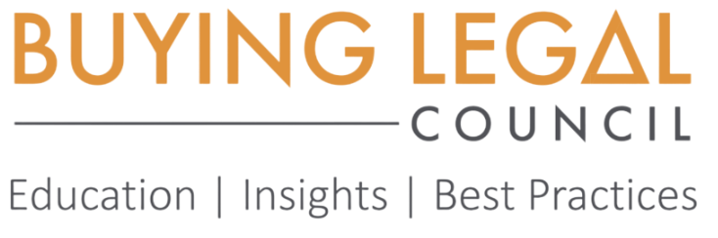
2023 Legal Procurement Awards
The Buying Legal® Council, the international trade organization for Legal Procurement, is accepting applications for the 2023 Legal Procurement Awards. Our goal is to identify and acknowledge the best industry initiatives in areas of Legal Procurement.
“The Legal Procurement Awards showcase advances in legal procurement and honor those who are at the forefront of new developments. The Awards provide a measure of recognition for achievement on the most relevant dimensions of skill and creativity,” says Dr. Silvia Hodges Silverstein, CEO Emerita of the Buying Legal® Council.
Overview:
Who can participate?
Any client-side professional involved in the sourcing of legal services and managing supplier relationships can submit their project. Legal procurement consultants and other services providers may only submit their project together with their client.
Which projects qualify?
You can compete for the following Award categories:
- Innovation
- Collaboration & Teamwork
- Pricing
- ESG

Please read the information below to get a better sense of how your project fits in with our selection criteria. Submissions must relate to projects conducted in 2022/2023.
How are winners determined?
A group of experienced legal procurement professionals serve as Legal Procurement Award judges and determine the winners.
What is the prize?
Award winners will receive a trophy, certificate, and logo for use on their marketing materials or website. The award ceremony will take place during the 2023 Legal Procurement Conference in NYC on October 24/25, 2023. The winners will get recognition at the ceremony and through social media.

Award Categories:
INNOVATION
The winning team/individual has provided an innovation to their organization that significantly created value through improved performance and/or efficiency, or had positive impact on cost reduction, transparency, reduction of legal spend etc.
Innovation can be through particularly innovative use of technology, process improvement innovation or other innovative approaches.
Specifically: Focus on a specific project or initiative which was finalized successfully. The innovation should represent a new and creative approach or process that created value for the organization and improved performance.
COLLABORATION & TEAMWORK
The collaboration award is given to an individual/legal procurement team who conducted a successful project or initiative, for its excellent collaboration with another function from the same organization (cross-functional) or with an external partner. The team successfully accomplished goals, was an honest and dependable player who contributed to group collaboration. The people involved showed empathy and respect for others and built and maintained good working relationships with internal stakeholders, other functions and external legal-services providers.
Specifically: Focus on a specific project or initiative which was finalized successfully. Focus on the role played by the Procurement professional or team in the collaboration and how this has successfully influenced the outcome.
PRICING
The winning team/individual has created and successfully implemented a creative, novel approach to pricing legal services that not only has managed to align the interests of both the buyer and the seller of legal services, adding significant value to the buyer (e.g. through savings, predictability of cost etc.), but at the same time, maintained or increased quality and helped improve the relationship with the provider.
Specifically: Focus on a specific project or initiative which was finalized successfully. Please focus on how it added value to both the buyer and the seller and how it improved the strategic nature of the relationship.

ESG
The winning team/individual has created and successful implemented an ESG (environmental, social and governance) initiative. The winning team/individual has created and successful implemented a creative, novel approach to any aspect of ESG such as diversity/inclusion/belonging or sustainability/social impact when buying legal services. You were able to significantly move the needle.
Specifically: Focus on a specific project or initiative which was finalized successfully. Please explain how your initiative had significant impact on any aspect of ESG.

Instructions:
How do you participate?
Only complete entry forms will be accepted and evaluated. A US$200 processing fee must be paid in full for awards consideration. If any parts of your submission should be considered confidential, please print CONFIDENTIAL in upper case before the relevant section or paragraph. Please note that the Synopsis part may not contain any confidential information.

To complete your submission, please email the following information to Doria Delgado-Thompson at doria@buyinglegal.com by Monday, August 28, 2023 in word document form. If additional information or context is necessary, you may include it as an attachment.

2023 Legal Procurement Awards
Submission Information
BASIC INFORMATION:
- Name:
- Organization:
- Address:
- Phone Number:
- Email:

SYNOPSIS: Briefly describe your project and tell us what makes your project special and "award winning." Please note that your synopsis may be featured in Award-related communication. (75-100 words)
PROJECT GOAL: Describe the goal you wanted to achieve
STRATEGY: Share/Describe your strategy: How did you intend to reach your project goal? (50-75 words)
IMPLEMENTATION: What steps did you take to implement your strategy? Please list your activities, both ongoing and one-time occurrences. (100-150 words)
RESULTS: Describe the outcome of this project, supporting it with data and evidence of your success (75-100 words)
ROI & BUDGET: What was the project's ROI? What budget did you have for it? If you completed the project internally, please give information about time, staff, and resources used to complete the project. (50-75 words)
WHY YOU?: Let us know what makes your project special and why you should win. (50-100 words)

